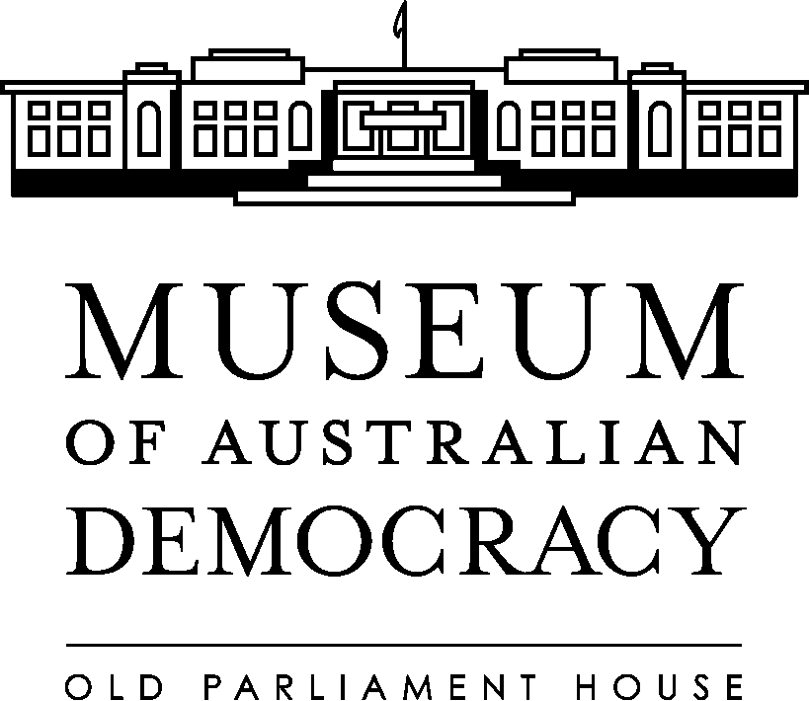

Old Parliament House - IPS information holdings

Who we are
The Museum of Australian Democracy at Old Parliament House is an Executive Agency within the Attorney-General’s portfolio that is dedicated to telling the story of the journey of our democracy. The museum provides a range of innovative exhibitions, tours, interpretation, education programs and public activities that will inspire and challenge visitors to explore democracy from its ancient roots to the present day and possible futures.
The museum links the past, present and future of Australian democracy with the history and heritage of the building providing visitors with a holistic and integrated experience. The museum encourages visitors to discover what it means to be Australian in one of Australia's most loved buildings and to be inspired by Australia's greatest achievements - our democracy - and the role they can play in it. The museum is a rare combination of place and content - showing what happened in the very place most democratic decisions that shaped our nation were made and creating a sense of admiration and appreciation for the visitor.
The aim is for visitors to come away feeling empowered, proud and motivated to play their role in Australia's democracy. The museum also oversees the provision of catering and conference facilities.

What we do

The agency is funded by the Australian Government to achieve one outcome:

Outcome 1: An enhanced appreciation and understanding of the political and social heritage of Australia for members of the public, through activities including the conservation and upkeep of, and the provision of access to, Old Parliament House and the development of its collections, exhibitions and educational programs

This outcome is delivered through one program:
- Program 1.1— Conserve, preserve, develop and present OPH as the Museum of Australian Democracy.

The organisational chart provides information about the agency’s structure.

Details of the resources available to the agency through Government funding can be obtained from the Portfolio Budget Statements. Old Parliament House reports on its achievements in its annual report. Plans and priorities for the future are outlined in the agency’s strategic plan.

The following documents outline policies and procedures used by the agency:

- Heritage Management Plan 2008-2013

The Heritage Management Plan satisfies Old Parliament House’s and the National Capital Authority’s obligations under the Environment Protection and Biodiversity Conservation Act 1999 for Old Parliament House and Curtilage. Assisted by heritage consultants and an expert advisory panel, the plan was written by Old Parliament House staff for the then Minister for the Environment, Water, Heritage and the Arts.

The plan provides a management and administrative framework ensuring all the heritage values are identified, well managed, interpreted and made available for community appreciation and enjoyment.

Our reports and responses to Parliament

The agency prepares an annual report for the Minister which is tabled in Parliament. The most recent annual reports are available on our website.

On 3 December 1998 the Senate adopted a recommendation of the Finance and Public Administration References Committee that varied the tabling requirements under the Senate Continuing Order No. 5 (the Harradine motion). Under the varied Order, agencies are now required to publish lists of files created, at half yearly intervals.

Routinely requested information
Through its Disclosure Log, OPH publishes information contained in documents that have been released under the FOI Act.

Arrangements for public consultation
The FOI Act requires agencies to report whenever an agency administers or establishes a public consultation arrangement in the course of developing a specific policy proposal, including how and to whom a comment may be submitted by members of the public.

- OPH currently does not have any proposals or arrangements that are relevant to this FOI Act requirement.
- If circumstances change, the agency will publish information on this page.
The Old Parliament House Advisory Council’s advice is sought in the development and implementation of a wide range of policies and proposals.
The Heritage Management Plan requires management to maintain ongoing consultation with community and government bodies regarding any proposed actions that would affect the site’s heritage values.
The agency also liaises with relevant groups and organisations on key common issues, policies and programs as appropriate. In particular:
- a wide range of relevant organisations are represented on the Round Table of Prime Ministerial Research and Collecting Agencies
- relevant professional organisations and collecting agencies make up the selection panel for Australian Prime Ministers Centre fellowships and summer scholarships
- an Expert Reference Panel was established during 2009–10 to assist in the future development of the Museum of Australian Democracy and the Australian Prime Ministers Centre. The first meeting of a working group drawing on members of the panel took place in May 2010, to advise on the development of an online version of the Australian Democracy exhibition timeline.
Visitors are also encouraged to provide feedback on their experiences, and their comments are taken into account in planning and developing programs.

Contact us
Contact details are located on our website.

Optional information to be published under the IPS
Under the FOI Act, agencies are encouraged to publish more than just the required categories of information. Therefore, consistent with advice from the Office of the Australian Information Commissioner, OPH also publishes:

Our priorities: Strategic plan and Service Charter

Our finances: financial information, pay and grading structures, and annual procurement plan.

Our lists: contracts and file lists

OPH currently does not have any data sets.
If circumstances change, OPH will publish information on this page.

Our submissions:

OPH currently does not have any submissions.
If circumstances change, OPH will publish information on this page.

Our policies: under consideration

Routine reporting of the following information is a requirement of the government:
- Expenditure on legal services
- Personal Information Digest
In addition, the agency publishes Prime Facts leaflets which give information about all our former prime ministers, their political careers and main achievements, their character and their lives after politics.

You can also find information about our collection.

Access charges for documents not available on the website

Some documents are impracticable to publish online.

A person seeking access to any of these or other documents not discussed above may contact the FOI contact Officer to arrange access.

Charges may be imposed for making that information available. Charges will be consistent with charges in the Freedom of Information (Charges) Regulations 1982 (which generally apply to access requests under Part III of the FOI Act).

