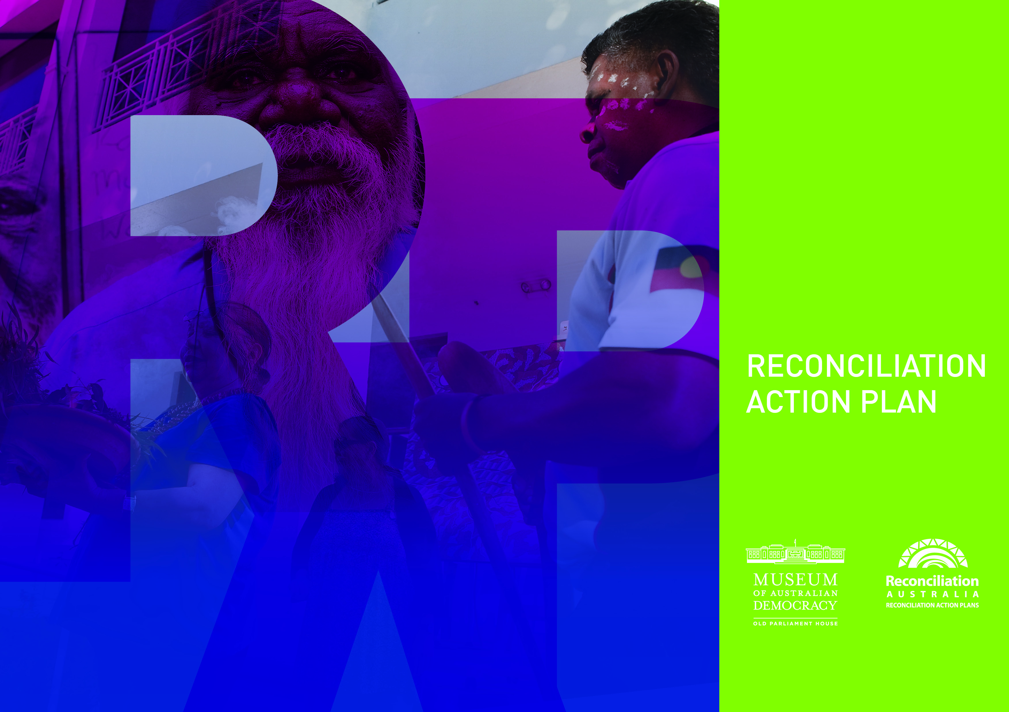

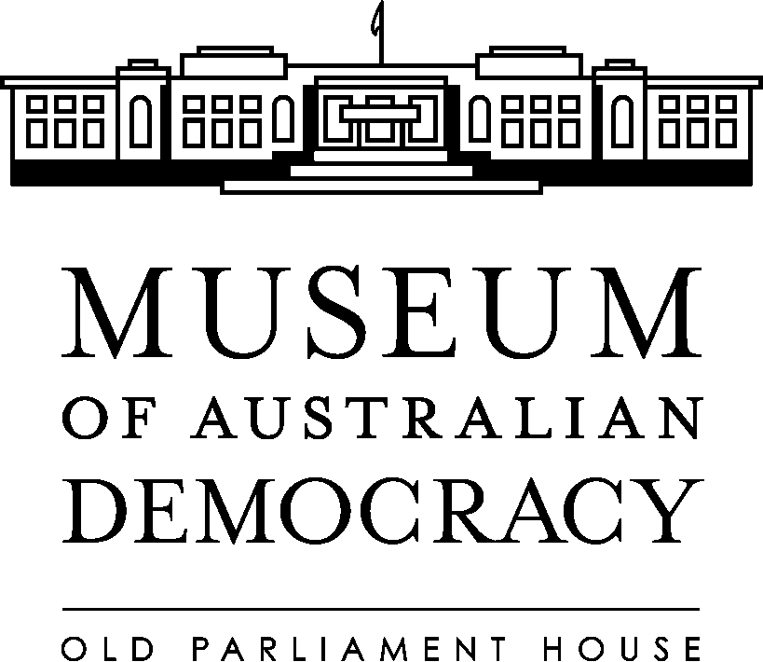**Our Vision for Reconciliation**

Our vision for reconciliation is one where an improved general awareness of the culture and history of Australia’s First Peoples will contribute towards greater understanding between Aboriginal and Torres Strait Islander and other Australians. Through our Reconciliation Action Plan (RAP) we will build better organisational understanding of Aboriginal and Torres Strait Islander cultures and histories. We will do this by providing training to our staff and promoting reconciliation within the Government and Museum sectors across Australia including promoting the status and well being of Aboriginal and Torres Strait Islander peoples. Such actions may enhance the quality of our exhibitions and events.

**Our Business**

The museum provides a focus for all of the people of Australia to celebrate, debate and experience the journey of Australian Democracy; providing an enhanced appreciation and understanding of the political and social heritage of Australia for all members of the public, through activities including the conservation and upkeep of, and the provision of access to, Old Parliament House and the development of its collections, exhibitions and educational programs. The museum is visited each year by almost 200,000 people, school groups and community groups make up a significant number of these visitors.

**Our RAP**

Our Reconciliation Action Plan ­has been developed in conjunction with Reconciliation Australia, the Department of the Prime Minister and Cabinet and staff within the museum. We will report all of our achievements in our Annual Report.

Director's Signature

Jenny Anderson

Director

17 August 2011

**Relationships**

We aim to build mutually respectful consultative relationships between Aboriginal and Torres Strait Islander and other people across the organisation through our core business activities to ensure that our exhibitions and events are culturally appropriate and appreciated by all Australians.

| **Focus Area: Participation** | | | |
| --- | --- | --- | --- |
| **Action** | **Responsibility** | **Timeline** | **Measurable Target** |
| Reconciliation Action Plan implementation overseen by the RAP Working Group. | Manager, Human Resources & Governance in consultation with Executive Management Group | February 2012  August 2012 | Biannual RAP Working Group meetings  Biannual RAP Working Group reports to Executive Management Group  RAP Working Group includes both Aboriginal and Torres Strait Islander and other staff or stakeholders |
| Develop strategies to encourage Aboriginal and Torres Strait Islander people and organisations to become involved with the museum and maintain and further develop content in programs and activities. | Manager Visitor Experience | January 2012 | Develop, display and tour an exhibition with significant Aboriginal and Torres Strait Islander content. |
| Build effective relationships between Aboriginal and Torres Strait Islander and other people both within and outside the organisation. | All Staff | Report by 30 June 2012 | Consultation with Aboriginal and Torres Strait Islander communities in relation to museum content development.  Maintain relationships with local and national leaders. |
| Invite Aboriginal and Torres Strait Islander guest speakers to speak with museum staff. | All Staff | Report by 30 June 2012 | Number of guest speakers invited and attending. |
| Support staff to attend relevant Indigenous seminars and conferences to build relationships with Aboriginal and Torres Strait Islander people. | All Managers | Report by 30 June 2012 | Number of seminars and conferences attended. |

**Respect**

Management and staff are committed to reconciliation between Aboriginal and Torres Strait Islanders and other Australians. We will continue to foster and improve respect for Aboriginal and Torres Strait Islander peoples, cultures, land, and histories both within the organisation and through its core business activities so that Aboriginal and Torres Strait Islander people can be better represented in our exhibitions and events for the benefit of all Australians.

| **Focus Area: Cultural Awareness** | | | |
| --- | --- | --- | --- |
| **Action** | **Responsibility** | **Timeline** | **Measurable Target** |
| *Welcome to Country* audio-visual loop presentation of the Welcome to Country given at the 9 May 2009 launch of the Museum of Australian Democracy shown in Kings Hall. | Manager, Interpretation & Programs Branch | Ongoing | *Welcome to Country* audio visual continues to be presented in the museum to visitors*.* |
| |  | | --- | | Develop and implement protocols for Acknowledgement of Country and/or recognition of traditional owners at events and when delivering programs to school groups, tours and public programs. | | Interpretation & Programs Branch | December 2011  (guidelines are in development in conjunction with local Elders)  Ongoing  As Required | Agency guidelines on acknowledging traditional owners developed and made available on intranet.  Acknowledgement of Country by museum staff continues at all schools presentations and public events.  Traditional owners continue to be invited to perform Welcome to Country at significant public events (as per agency guidelines). |
| Inclusion of Aboriginal and Torres Strait Islander elements in programs for visiting primary, secondary and tertiary students. | Interpretation & Programs Branch | Report by 30 June 2012 | Aboriginal and Torres Strait Islander content will be included in school programs. |
| Increase staff awareness and understanding of Aboriginal and Torres Strait Islander cultures and reconciliation. | HR & Governance | December 2011 | RAP is included in staff induction from commencement.  Interpretation and programs staff undertake cultural awareness training. |
| Celebrate significant Aboriginal and Torres Strait Islander events including National Aborigines and Islanders Day Observance Committee (NAIDOC) week. | All Staff | 1- 8 July 2012 Annually | Mark NAIDOC week with a special event for staff.  Relevant screen saver designed and run on intranet during NAIDOC week.  Annual Report to include number and type of events celebrated. |
| Display Aboriginal and Torres Strait Islander flags in a prominent location. | Corporate & Heritage Branch | 27 May – 3 June 2012  1-8 July 2012 | Both flags are displayed during NAIDOC and Reconciliation weeks. |

**Opportunities**

Provide opportunities for Aboriginal and Torres Strait Islander people, organisations and communities to ensure that the museum is representative of Aboriginal and Torres Strait Islander people and their views.

|  |  |  |  |  |
| --- | --- | --- | --- | --- |
| |  | | --- | | **Focus Area: To increase opportunities for Indigenous people.** | | | | |
| **Action** | **Responsibility** | **Timeline** | **Measurable Target** |
| Ensure that the Enterprise Agreement and managers provide Aboriginal and Torres Strait Islander staff with access to cultural leave. | Corporate & Heritage Branch | Report by 30 June 2012 | Statistics on leave taken by Indigenous staff to attend cultural ceremonies and NAIDOC ceremonies. |
| Indigenous Contact Officer to continue to provide a focal point for staff inquiries. | HR & Governance | August 2011 | Existence of role to be publicised internally.  Level of activity reported in Annual Report. |
| Participate with other cultural institutions in the development of policies and programs that are cognisant of the needs of Aboriginal and Torres Strait Islander people and support reconciliation. | All Managers | Report by 30 June 2012 | Number of policies and programs developed or reviewed and forums attended. |
| Agency agreement to support Indigenous APS Employees Network (IAPSEN). | Executive  Management | 30 Dec 2011 | Seek approval to place Museum of Australian Democracy (MoAD) logo on IAPSEN website.  Provide indigenous employees with the opportunity to attend IAPSEN meetings. |
| Advertise employment opportunities in Indigenous-specific media and ensure the MoAD Website and job application packs contain a statement that the agency embraces diversity and welcomes applications from candidates of all backgrounds. | HR & Governance | Report by 30 June 2012 | |  | | --- | | Number of employment opportunities listed in Indigenous-employment publications. | |

|  |  |  |  |  |
| --- | --- | --- | --- | --- |
| |  | | --- | | **Focus Area: To increase opportunities for Indigenous people.** | | | | |
| **Action** | **Responsibility** | **Timeline** | **Measurable Target** |
| Actively work towards achieving 2.7 per cent COAG target for Indigenous employment by 2015 by seeking opportunities for cross portfolio training and development including mobility, work experience and mentoring schemes. | HR & Governance | Report by 30 June 2012 | Progress reported in Annual Report and at RAP Working Group meetings.  Report annually to Reconciliation Australia. |

**Tracking Progress and Reporting**

| **Action** | **Responsibility** | **Timeline** | **Measurable Target** |
| --- | --- | --- | --- |
| Report progress in Annual Report. | HR & Governance in consultation with EMG | 1 October 2012 | RAP progress reported in Annual Report and reported annually to Reconciliation Australia.  RAP Report used to refresh the RAP. |
| Annually refresh RAP in consultation with Reconciliation Australia. | HR & Governance in consultation with EMG | August 2012 | RAP endorsed by Reconciliation Australia and the Museum and available on the intranet and internet.  RAP available on RA website. |