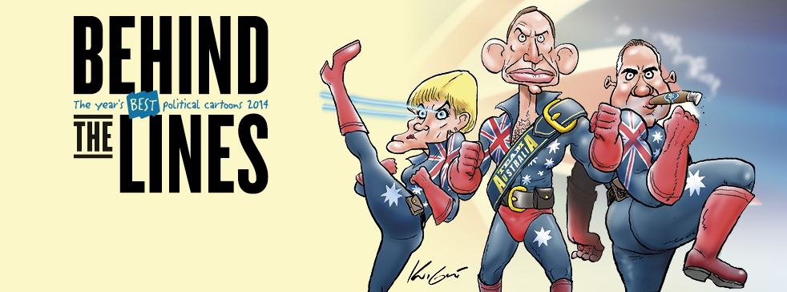

Teacher-facilitated experience for schools

Session Aims

Students explore the year’s best Australian political cartoons created during 2014. Produced by 33 cartoonists, the 80 works capture a range of points of view from which students can consider and analyse recent political history.

The program can also combine with the Museum of Australian Democracy’s (MoAD) Zine Lounge, where students of all ages can engage in an alternative to mainstream media, the uncensored voice of the people and an exercise in freedom of speech. Inspired by the celebrated cartoonists viewed in Behind the Lines 2014, students use their creative voice on issues of personal and political importance to create their own zine using stationery and art materials provided in the Lounge.

Alternatively, the program can be combined with a visit to Power of 1 an interactive exhibition exploring how Australian’s attitudes towards democracy and politics have shifted through the generations. This exhibition celebrates the voice of the people and gives older students (years 10-12 only) opportunities to question political processes and explore what matters to them.

Where can we do Behind the Lines Self-Guide Program?

Behind the Lines 2015 is located in the Downstairs Gallery. If desired, the teacher-facilitated learning program can also incorporate the Zine Lounge, located on the ground floor at the Museum of Australian Democracy.

What does the Behind the Lines Self-Guide program cover?

This program is led by the teacher, the content and focus is determined by the class requirements and preferences. Students will need to be directed by teachers or supervising adults during their time in the exhibition gallery. It is highly recommended that you familiarise yourself with the exhibit themes and content in preparation for your visit, themes are cartoons can be viewed online.

Additional resources are included at the end of this guide. These include resources on the process of creating political cartoons, how to read political cartoons, and videos on cartooning techniques. There are also other sites on drawing as well as information on some of the contemporary political events that inspired the 2014 Behind the Lines exhibition. For further perspective, links to previous year’s exhibitions have also been included. Resources may be utilised in class preparation for the visit, or to follow up in the classroom.

General Program Information

Program is designed for students in Years 6-12
Bookings are essential, to book:

Email bookings@moadoph.gov.au
Phone (02) 6270 8282

Please advise if you wish to also book a Zine Lounge or Power of 1(Years 10-12 only) program with your booking.

- Welcome and farewell by MoAD Educator
- Facilities provided by MoAD Educator
- Program overview & links
- Behind the Lines visit facilitated by class teacher and supervising adults
- Supervision throughout the program is the responsibility of the school, minimum ratio one teacher/adult per 10 students

Cost

- $2 per student; no additional cost for the Zine Lounge or Power of 1 program

Suggested Session timing

This program can be adapted in length to suit the objectives for your class. If, for example, the program is combined with a Zine Lounge experience we suggest adding at least an extra 30 minutes for the creative element. Additional time may also be required if you wish your students to undertake in-depth analysis of cartoons while on site.

Lower year levels will finish looking at the cartoons in under 30 minutes; the program can be offered as a 30 minute experience. Alternatively, with pre-negotiation, upper primary and lower high school students may be seated with some basic drawing supplies and could spend some time cartooning their own ideas.

We suggest allowing an hour for upper high school students, and providing them with specific tasks to complete during their viewing.

Remember, for any year level, the program can be combined with the Zine Lounge, which also provides opportunity for a creative response celebrating freedom of expression.

Years 6-8

10 minutes
- Welcome and orientation to physical spaces - MoAD Educator
- Introduction to political cartooning, exploration of the cartoon of the year, Team Australia
- Outline of three characteristics of political cartoons

10-15 minutes
- Exploration of the exhibition, students are able to self guide through the exhibition space

5-10 minutes
- Debrief together as a group.

Years 9-12

10 minutes
- Welcome and orientation to physical spaces - MoAD Educator
- Orientation to the student expectations (what you want them to focus on during their time, any assignment they need to work on back in class, cartoons or themes you want them to take specific note of etc) – class teacher

30 minutes
- Students and accompanying adults are free to look at the cartoon exhibition, this is not structured by or supervised by MoAD staff.

10 minutes
- Debrief
- Program conclusion and exit

Australian Curriculum Links (Year 6-12)

Civics and Citizenship:
- Government and democracy
- Citizenship, diversity and identity
- Develop questions and gather a range of information to investigate society
- Identify different points of view
- Problem solving and decision making
- Communication and reflection
- Analysis, synthesis and interpretation

History
- Analysis and use of sources
- Perspectives and interpretations
- Explanation and communication

The Arts
- Media Arts
Evaluate how technical and symbolic elements are manipulated in media artworks to create and challenge representations, social beliefs and values
Analyse a range of media artworks from contemporary and past times
Analyse how technical and symbolic elements are used in media artworks
- Visual Arts
Analyse how artists use visual conventions in artworks
Evaluate displays of artworks

English
- Interpreting, analysing, evaluating
- Literature and context
- Responding to literature
- Text structure and organisation
- Examining literature
- Expressing and developing ideas
- Creating texts
- Interacting with others
The Zine Lounge activity, and Power of 1 have additional links to a range of Australian Curriculum requirements, please refer to the Zine Program Outline and the Power of 1 Outline for additional information.
Classroom Resources: Political cartooning
Behind the Lines: The Year’s Best Political Cartoons brings together a selection of the best works entered in the 2014 Political Cartooning Competition. In thinking about political cartoons, here are some links about cartooning for you to explore.
- ‘Laughing with knives’ | National Museum of Australia
- Reading between the lines | National Museum of Australia
- Understanding the World of Political Cartoons | World Affairs Council
- It’s No Laughing Matter | Library of Congress
- Decoding political cartoons | Library and Archives of Canada
- Billy Hughes at War: How to read a political cartoon | Museum of Australian Democracy
- Cartoon Analysis | John Curtin Prime Ministerial Library
- Cartoon PD in a Package | John Curtin Prime Ministerial Library
- Cartoons for the Cause: Cartooning for Equality in Australia | Australia Media Traditions Conference 2001

Cartoonists talking about cartooning
- Herb Block | Library of Congress
- Judy Horacek
- Alan Moir

Cartooning techniques
- Bruce Petty video | National Film and Sound Archive
- Alan Moir

Other useful drawing tips and sites
- Drawing it out with David Pope
- Drawing it out with David Pope - the mining tax
- John Frith: The Art of Politics
- Dr Seuss Went to War | UC San Diego Library
Behind the lines Exhibition

Each cartoon from the previous and current exhibits can be viewed online. Follow the links below to look at Australia’s recent political history told through cartoons.
- 2011
- 2012
- 2013
- 2014
Resources: Current Events
These links are to basic news articles outlining several of the most influential events over 2014, featured in Behind the Lines. They may be used as preparation for your visit, as a contrasting medium for presenting current events and political comment or as resources for a follow-on classroom project
- Operation Sovereign Borders
- Medicare Co-Payment
- University fees and HECS Debt
- Freedom of Speech
- Charlie Hebdo 1, Chalie Hebdo 2
- Metadata Legislation
Example classroom activities
- Investigate cartoons made by one cartoonist throughout their career, ie Frith – identify metaphors and the way they mine the history of cartooning.
- Onsite – choose a cartoon and identify how it depicts and relates to the theme it has been categorised in
- Post-visit activity: collect political cartoons throughout a 6-12 month period, then group selected cartoons into themes

For further classroom resources and learning support regarding political cartooning, please visit Schools Resources

